**Palm Pattern Recognition using Feature Detection**

Jayamathan.S1, Kishorr.S.R2, Dheena Dhayalan.T3

*B.E.,IV Year, Sri Ramakrishna Engineering College*

[jayamathanskj03@gmail.com1, kishore.suganthi@gmail.com2](mailto:jayamathanskj03@gmail.com1,%20kishore.suganthi@gmail.com2), dheenadhayalan@gmail.com3

**Abstract-- Oriented FAST and rotated BRIEF (ORB) is a fast robust local feature detector that can be used in computer vision such as feature detection. It is based on combination of fast key point detector and visual descriptor binary robust independent element features. Using this method palm pattern can be acquired, matched, recognized, authenticated which provides fast and efficient alternative to SIFT. SIFT key point detector have proven efficient in number of application such as object recognition, image stitching and visual mapping. However it imposes a large computational burden in real time systems. Oriented FAST and rotated BRIEF act as a best replacement with lower computational cost. For this purpose we apply oriented FAST and rotated BRIEF are applied on palm pattern images and their matching evaluation parameters are computed.**

**Index Terms-- Biometrics, OpenCV, Image processing,palm pattern recognition, scale invariant feature transform, feature detection, oriented FAST and rotated BRIEF**

I. INTRODUCION

Due to development of science technology the traditional authentication such as passwords, finger print authentication, smart cards are in capable of meeting the requirements of security purposes. Under such circumstances biometric security techniques take advantage of humans intrinsic and extrinsic characters such as physiological (face, iris, finger print, hand shape) and behavioral (signature, hand writing). Among these fingers print recognition is popular for identifying individuals based on their finger print pattern. However finger print recognition can have negative effect due to wounds, oil patches, dirt and age disorders. Also this technique is easily exposed to fraudulent because it can be easily extracted from any individuals. In contrast some intrinsic characteristics such as palm pattern and DNA are more difficult to forge because they are deep in the body and more challenging to acquire. Therefore palm patterns take great advantage of high anti counterfeiting. Palm patterns are network structures of blood vessels that are present in the skin and can be acquired in vivo only when employing infra red illumination which effectively protects against external damages, impersonation and spoof attacks. The texture of palm patterns of different individuals has been proven to be distinctive even among identical twins. All the above mention features make it a promising alternative for person identification.

II. LITERATURE SURVEY

In general, vein patterns include palm veins, hand dorsal veins, finger veins, wrist veins, forearm veins and sclera veins, where palm pattern is superior to the other patterns because of the abundance of biometric characteristics and convenience of palm image acquisition, which has been established by Macgregor in, and numerous palm print identification algorithms have been proposed in the literature. However, extracting the representative palm vein features requires further more exploration. The prevalent approaches seek to establish suitable palm pattern characteristics for feature extraction or are derived from methods developed for face recognition, finger recognition, palm print recognition, iris recognition, and so on, which are summarized as follows.

➢ Methods based on Geometry derived from fingerprint and palm print recognition that utilize approximate line-like, curve, and point information, that are highly dependent on the chosen coordinate system. Hence, the region of interest (ROI) extraction and position calibration must be considered. Geometry features pose difficulties in extraction, representation, and matching, as well as suffer from information loss owing to small and/or blurred textures. Therefore, these methods have poor distinguishing ability and are also sensitive to scaling, rotation, and displacement.

➢ Methods based on statistics employ

Statistical information, like local binary histogram and moments, and categorized into global and local statistics methods. For example, local statistical based methods include local binary patterns (LBPs) local derivative patterns (LDPs) and their variants that are also sensitive to scaling, rotation, and displacement. Global statistical-based methods consist of invariant moments, which are invariant to scaling, rotation, and displacement, wavelet moments, gradient fields, and so on.

➢ Methods based on local variant, inspired by the approaches emerging from computer vision, such as SIFT, SURF, extract local invariant features directly rather than first employing preprocessing. However, due to the lack of grayscale shift and corners, the number of extracted local invariant feature points is small and also exhibit large interclass changes; So, some image enhancement should be performed before local invariant-based methods are adopted for palm vein identification.

➢ Methods based on Appearance-based (subspace-based), including PCA, LDA, ICA, NMF, and their kernel version, manifold method (OPNN), take subspace coefficients as features without prior knowledge. These can be separated from the above mentioned methods and viewed as an issue in the pattern recognition domain. Appearance-based methods are utilized for feature extraction, adopting both artificial intelligence and machine learning methods for classification.

III. PALM PATTERN ROI SEGMENTATION

Input palm pattern image

Reference samples

BGR to grayscale conversion

BGR to grayscale conversion

ROI selection

Key Point detection

Feature detectors

Oriented FAST and rotated BRIEF

Distance Measurement

Pattern recognition

Fig 1.Schematic overview of proposed approach

Contactless palm pattern has advantage such as hygiene, non contact acquisition; it has gained higher user acceptability. The process involves various pre processing steps such as ROI extraction, gray scale conversion.

Our proposed palm pattern segmentation involves oriented FAST and rotated BRIEF method. First a modified palm pattern images are taken where ROI selection is performed. And following that BGR images are converted to grayscale images. Next oriented FAST and rotated BRIEF algorithm is applied on those images. Based on that, images are matched on distance measurement and feature detection.

A. Segmentation of Hand Shape

Extraction of palm vein ROI includes hand shape segmentation. Our previous related work shows that segmentation of colored images result in negative effects. So before segmentation BGR images must be converted into grayscale images. Additionally due to lighting conditions, poor contour images will occur. So an effective algorithm is implemented to reduce the noisy region. Oriented Fast and rotated BRIEF is used to obtain threshold which is used to segment the hand shape.

B. ROI Extraction and Normalization

To extract a ROI from palm pattern image midpoint of palm pattern is taken as reference. A bilinear gray value differential method is used to perform scaling and rotation correction for palm pattern image normalization. The square of the normalization define the palm pattern ROI.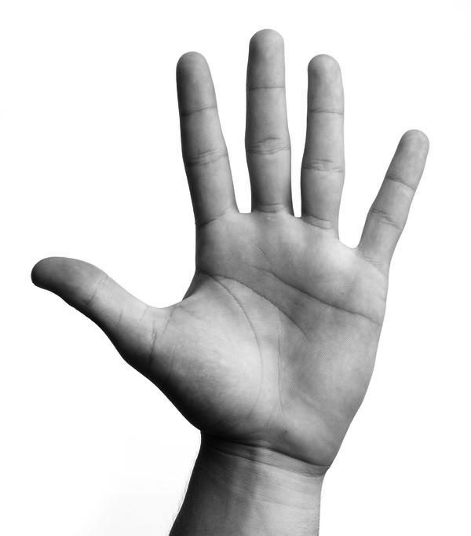

Fig 2.Segmentation and ROI extraction

IV. MATCHING APPOROACH

A. Key Point Detection

Key points are interest points that are spatial locations or points in the image that define what is interesting or what stand out in the image. This is important because n matter how the image changes such as image rotates, strings or distortion key points will remain the same. It is different from the frameworks by the way describing the key points. Each key point detects an associated descriptor that accompanies it. Key points are detected regardless of orientation and scale but location matters. However to match key points between images then scale and orientation plays an important role. Only after extracting the key points the information about position and coverage area of the image can be retrieved. Each algorithm has some characteristics to extract key points (they are centered around blobs, edges, corners that are prominent).

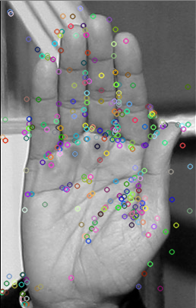

Fig 3.Key point Detection

B. Matching Images

Images are arrays of rows and columns that are arranged as pixels. Each pixel is located in their respective rows and columns. So key points will also share a location of rows and columns. Based on the key points that are detected on target palm pattern image and reference palm pattern image, key points are matched based on distance measurement in target and reference image. Number of key points can be increased or decreased based on the image for our convenience

Template matching is used to match binary and non binary images however the pattern used in this approach are binary because ROI extracted from contactless palm image will result in deviation of some degree that will affect recognition performance when using template matching on the ROI image.

Matched key points on reference and target images will be identified by drawing lines between the key points. Number of matching key point lines indicates the image matching percentage accuracy.

Percentage matching indicator is displayed as graph of x and y axis from where target and reference images are compared directly using structural similarity (SSIM). It is an indexed method for predicting digital images and videos. SSIM index is a full reference metric which is a measurement or prediction of images based on initial uncompresses or distortion free images reference. It is used to improve peak signal to noise ratio and mean square error.

These algorithms are used for matching images in our proposed project.

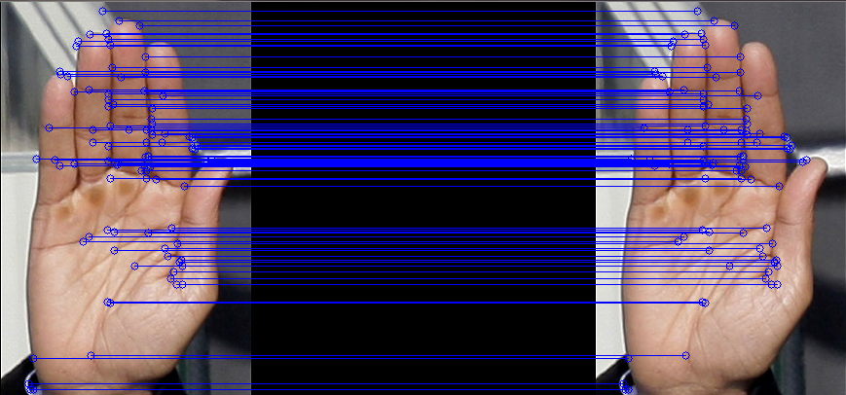

Fig 4.Image Matching based on key point distance measurements

V. ORIENTED FAST AND ROTATED BRIEF ALGORITHM (ORB)

Oriented FAST and rotated BRIEF is a fast robust local feature detector presented by Ethan Rublee et al. in 2011. It is used in computer vision tasks such as object recognition or 3D reconstruction, feature detection, image matching. It is based on fast key point detector and virtual descriptor binary robust independent elementary features. It provide fast and efficient alternative to SIFT or surf. It is good alternative to SURF and SIFT in computational cost, matching performance and patterns. It is a fusion of fast key point detector and brief descriptor with modification for enhanced performance. Initially it uses FAST to find key points and then apply Harris

Corner measure to find top N points among them. It use pyramid to produce multi scale features. It calculates weighted intensity centroid of the patch with located corner at centre. Vector direction from corner point to centroid gives orientation. For improving rotation invariance moments are computed with x and y that should be in circular region of radius, which is the size of the patch.

Brief has an important property that each bit has larger variance and mean near 0.5. But once it is oriented along key point direction, it losses this property and become more distributed. One another desirable property is to have the tests uncorrelated since then each test will contribute to result. To rectify this ORB runs a greedy such among all possible tests to find the ones that have high variance and mean and uncorrelated.

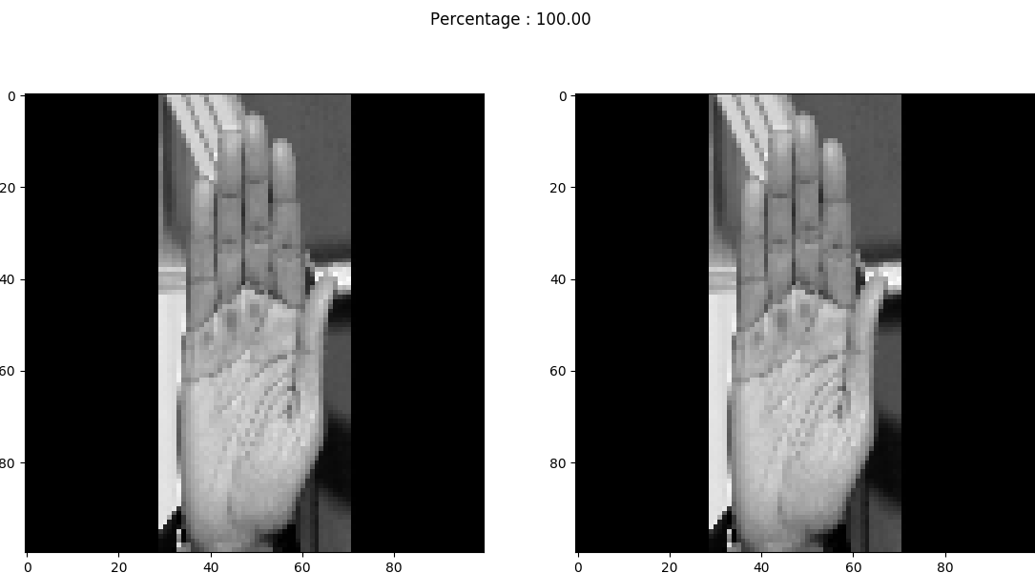

Fig 5.Image Matching percentage indication using structural similarity

VI. SOFTWARE DESCRIPTION

OpenCV (Open source Computer Vision) is aimed at real time computer vision consists of library of programming functions. It is cross platform and free for use under open source BSD license. It‘s primary interface is C++ whereas bindings are available in python, java and MatLab/Octave. It runs on variety of platforms such as windows, Linux, Mac OS, FreeBSD, NetBSD, OpenBSD. It also supports mobile operating systems such as Android, IOS, Blackberry and Maemo.

VII. CONCLUSION

Numerous studies have reveal that SIFT algorithm applied on palm pattern image has high accuracy due to its higher texture representation ability and high computational burden. However when operated on entire image due to high computational burden it cannot be applied on real time images. Comparative experiments and results demonstrated that oriented FAST and rotated BRIEF have low computational burden as compared with SIFT. Therefore our method can be extended to palm pattern recognition and achieve greater performance after employing ORB strategy. Our proposed method focus on contactless palm pattern images that is suitable for real world scenarios.

VIII. REFERENCES

1] A. K. Jain, R. M. Bolle, and S. Pankanti, Biometrics: Personal Identification

in Networked Society. Norwell, MA, USA: Kluwer, 1999.

[2] C. Simon and I. Goldstein, “A new scientific method of identification,”

New York State J. Med., vol. 35, no. 18, pp. 901–906, 1935.

[3] P. Tower, “The fundus oculi in monozygotic twins: Report of six pairs

of identical twins,” AMA Arch. Ophthalmol., vol. 54, no. 2, pp. 225–239,

1955.

[4] Fujitsu. (2006). Palm Vein Pattern Authentication Technology. [Online].

Available: http://www.fujitsu.com/downloads/COMP/ffna/palm-vein/

palmsecure_wp.pdf

[5] Y. Zhou and A. Kumar, “Human identification using palm-vein images,”

IEEE Trans. Inf. Forensics Security, vol. 6, no. 4, pp. 1259–1274,

Dec. 2011.

[6] L. Mirmohamadsadeghi and A. Drygajlo, “Palm vein recognition with

local binary patterns and local derivative patterns,” in Proc. Int. Joint

Conf. Biometrics, Oct. 2011, pp. 1–6.

[7] M. Fischer, M. Rybnicek, and S. Tjoa, “A novel palm vein recognition

approach based on enhanced local Gabor binary patterns histogram

sequence,” in Proc. 19th Int. Conf. Syst., Signals, Image Process.,

Apr. 2012, pp. 429–432.

[8] J.-C. Lee, “A novel biometric system based on palm vein image,” Pattern

Recognit. Lett., vol. 33, no. 12, pp. 1520–1528, Sep. 2012.

[9] Y. Zhou and A. Kumar, “Contactless palm vein identification using

multiple representations,” in Proc. 4th IEEE Int. Conf. Biometrics,

Theory Appl. Syst., Sep. 2010, pp. 1–6.

[10] C.-L. Lin and K.-C. Fan, “Biometric verification using thermal images

of palm-dorsa vein patterns,” IEEE Trans. Circuits Syst. Video Technol.,

vol. 14, no. 2, pp. 199–213, Feb. 2004.

[11] Y. Wang, K. Li, and J. Cui, “Hand-dorsa vein recognition based on

partition local binary pattern,” in Proc. IEEE 10th Int. Conf. Signal

Process., Oct. 2010, pp. 1671–1674.

[12] C.-B. Hsu, S.-S. Hao, and J.-C. Lee, “Personal authentication through

dorsal hand vein patterns,” Opt. Eng., vol. 50, no. 8, p. 087201, Jul. 2011.

[13] W. Yang, X. Huang, F. Zhou, and Q. Liao, “Comparative competitive

coding for personal identification by using finger vein and finger dorsal

texture fusion,” Inf. Sci., vol. 268, pp. 20–32, Jun. 2014.

[14] W. Kang, “Vein pattern extraction based on vector grams of maximal

intra-neighbor difference,” Pattern Recognit. Lett., vol. 33, no. 14,

pp. 1916–1923, 2012.

[15] E. C. Lee, H. C. Lee, and K. R. Park, “Finger vein recognition

using minutia-based alignment and local binary pattern-based feature

extraction,” Int. J. Imag. Syst. Technol., vol. 19, no. 3, pp. 179–186,

2009.

[16] H. C. Lee, B. J. Kang, E. C. Lee, and K. R. Park, “Finger vein

recognition using weighted local binary pattern code based on a support

vector machine,” J. Zhejiang Univ. Sci. C, vol. 11, no. 7, pp. 514–524,

2010.

[17] W. Song, T. Kim, H. C. Kim, J. H. Choi, H.-J. Kong, and S. R. Lee,

“A finger-vein verification system using mean curvature,” Pattern Recognit.

Lett., vol. 32, no. 11, pp. 1541–1547, Aug. 2011.